Komal Khan
CST – 315 Operating Systems
Dr. Citro
April 5, 2026
Project 5 - Short Term Process Scheduler

Description:
Short term scheduler is added to shell. Scheduler manages multiple processes created by user in the interactive mode. Main purpose is to decide which process should run, when one process should wait and when it returns to the ready state. Removing the process after completion is also necessary.
Scheduling Algorithms:
There are many scheduling algorithms like first come first serve, shortest job first, priority scheduling and round robin but in this scenarios round robin is used. In round robin each process is assigned a fixed time quantum in circular order. It works better for interactive shell. Round robin is a preemptive scheduling algorithm which means CPU time is a fixed amount that is given to each process.
Design:
Ready processes are stored in FIFO which supports round robin scheduling. Scheduler selects process at the front of the queue and once the process completes its job it is removed from the system. Shell keeps all the processes in PCB (process control table) so it can be modified later.
Implementation:
- How are you implementing the queue of process?
Queue is implemented as a ready queue. It stores all processes that are used by CPU. FIFO queue is used. Round robin works by taking process at front of queue, runs it for one time slice then place it back at the end if it still has remaining work. Shell also keeos process table so that all processes can be tracked by ID even when they are running.
- How is the scheduler assigning a reasonable share of the CPU to each process?
Fixed time quantum is used by scheduler to assign CPU time. A process is allowed to run only for that specific time slice then the scheduler moves it to next ready process. Because of it all processes get a fair and equal time of CPU. So if a processes needs more time it is sent back to ready queue to continue later. Meanwhile the shorter jobs may require only one cycle to complete.
- How do you maximize efficiency (i.e., minimize CPU idle time)?
Ready queues are active when there are processes present that needs to be run. When one process finish its job the scheduler selects the next process in the queue without nay delay. Processes waiting for I/O do not hold CPU so that the scheduler can assign CPU time to another ready
- How do you ensure quick reaction to user input?
Short time-quantum and preemptive scheduling technique are used to respond quickly to user input. Shell may react to freshly entered commands and newly created processes faster since no process is permitted to run uninterrupted for an extended period of time. This is crucial in interactive mode since the user anticipates that the shell will continue to function even when managing several processes.

- How do you ensure that the same job takes approximately the same amount of time when repeated?
By using the same queue rules, quantum size, and scheduling strategy each time a process is run, scheduler guarantees consistent behavior. The same task will receive comparable CPU access and take roughly the same amount of time to finish if it is repeated under comparable system conditions. System load may still cause some slight variance, but overall behavior is still predictable.
- How do you minimize the overhead (e.g., switching states)?
Selecting a suitable time quantum reduces overhead. The scheduler will waste CPU time by doing too many context switches if the quantum is too tiny. Responsiveness decreases if the quantum is too big. While maintaining system responsiveness, a balanced quantum size minimizes needless switching. By only relocating a process in response to actual events like time slice expiration, I/O requests, or termination, the solution also prevents needless state changes.
- How do you account for efficient resource utilization?
Separating process states lead to efficient resource utilization. To avoid using the CPU when inactive, a process that is awaiting input or output is placed in the wait state. Next, another ready process receives CPU time from the scheduler. This makes it possible for CPU and I/O time to overlap, increasing overall throughput and guaranteeing more equitable use of system resources.

- How do you avoid starving a process?
Every task in the ready queue advances to the front and receives CPU time. Round Robin scheduling prevents one class of processes from having total control over execution, in comparison to rigid priority-only scheduling. An aging mechanism can be implemented if priorities are employed, making a process that is waiting too long progressively more scheduling-friendly.
- How do you ensure that the shell does not collapse under increased load, but its performance is gradually degraded?
Increased load results in delayed response times rather than failure because of the shell's architecture. Additional processes are added, they have to wait longer in the ready queue before getting CPU time. Scheduler keeps processing them one at a time. The system maintains stability even under increased demand since the implementation makes use of regulated state transitions, process tables, and ordered queues. This indicates that rather than abruptly collapsing, the shell's performance steadily deteriorates.
- Is your scheduler preemptive or cooperative?
Preemptive scheduler is used. CPU is not retained by a process until it decides to release it. Rather, if there is still work to be done, the scheduler returns the process to the ready queue after interrupting it when its time quantum expires. One of the primary reasons Round Robin is appropriate for interactive systems is preemption, which enhances responsiveness.
- Provide the processes queuing diagram.

Running Ready (when time quantum expires)
Running Waiting (when I/O is requested)
Running Terminated (when process finishes)
Waiting Ready (when I/O completes)
Code output:
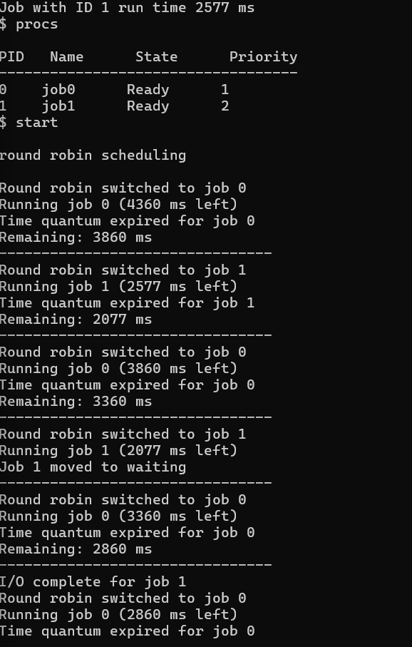
Github link:
https://github.com/KomalKhan776/CST-315-P5
References:
https://lass.cs.umass.edu/~shenoy/courses/fall12/lectures/Lec05.pdf
https://www.cs.uic.edu/~jbell/CourseNotes/OperatingSystems/5_CPU_Scheduling.html
https://stackoverflow.com/questions/33100196/completely-fair-scheduler-vs-round-robin
https://www.sciencedirect.com/science/article/pii/S0167637721001619

